**Basic Array Example flow**

Steps to follow

1. Create an Instant flow
2. Add an action Initialize an array called “Array1”
3. Then Add another action to append to array variable and add “item1”

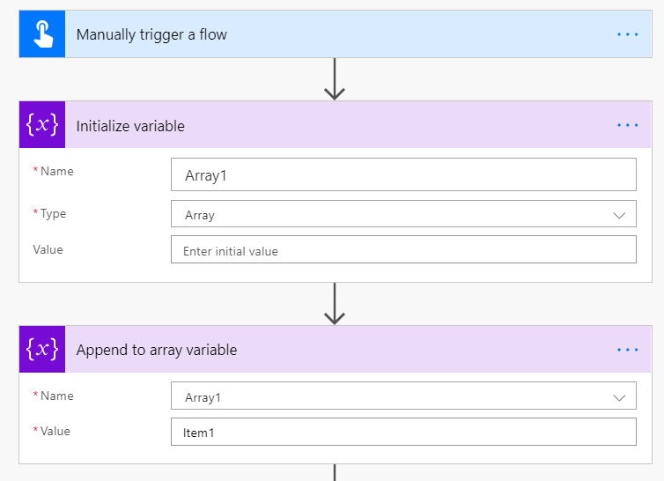

1. Then Add another action to append to array variable and add “item2”
2. Add and email action and add the array variable in the body

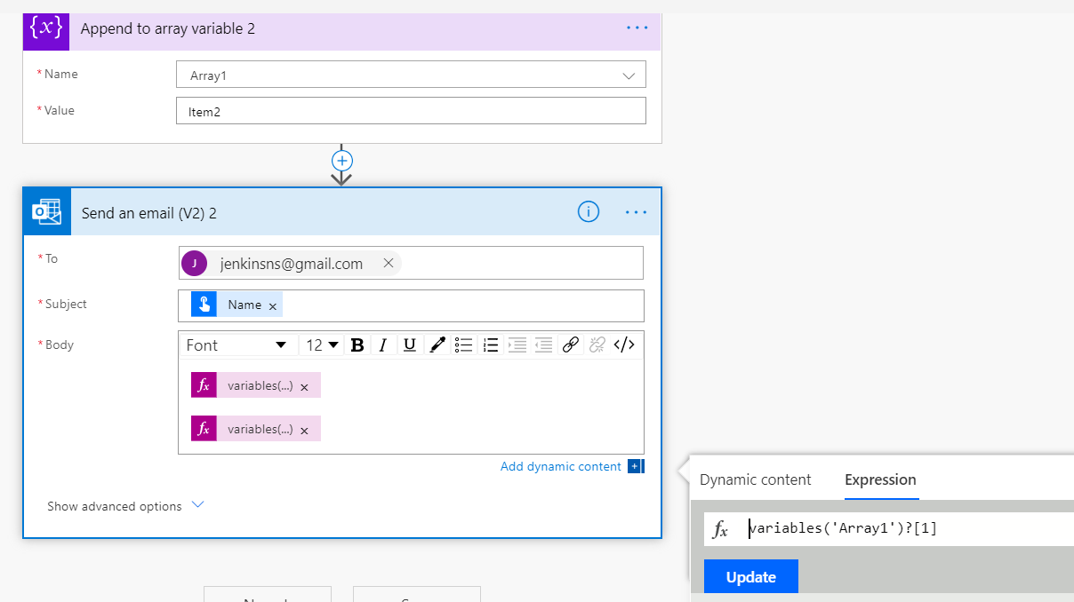

**Array flow example**

SP to array to HTML

Steps to follow:

1. Create a SharePoint list Countries with two columns Country and State
2. Add 5 records
3. Create an Instant flow
4. Add an action Initialize variable array1

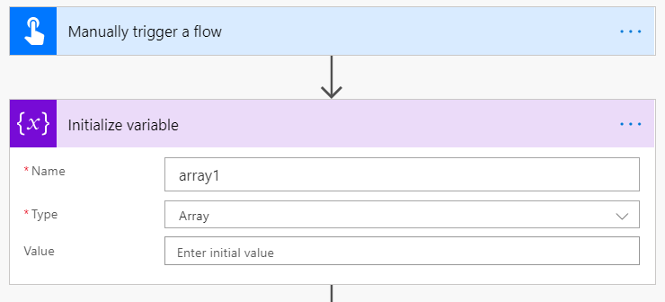

1. The add an action SharePoint 🡪 Get Items
2. Add Site address and List name

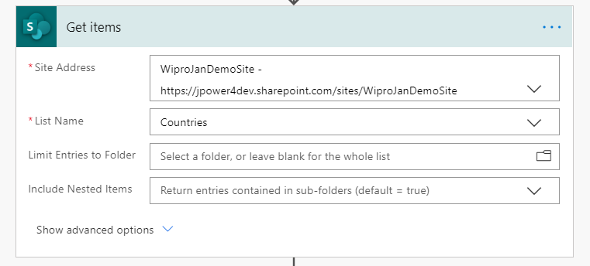

1. Add another action append to array variable
2. Set value from previous step output
3. Update the value column with country and state
4. It will loop using Apply to each

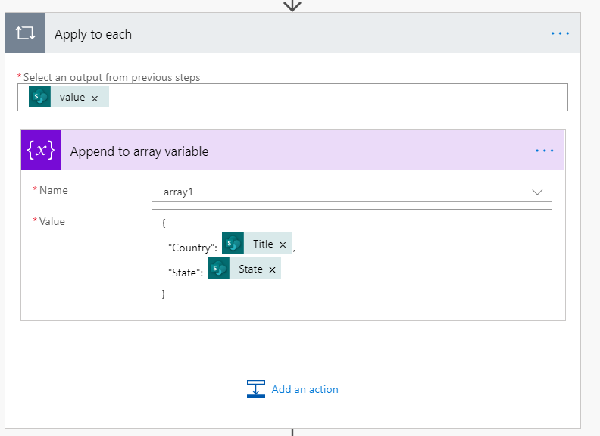

1. Add an action Create HTML table
2. Set the output from array1
3. If you want and custom columns and values

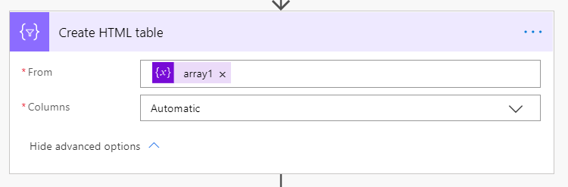

1. Add another action to send email
2. Add the outcome to email body

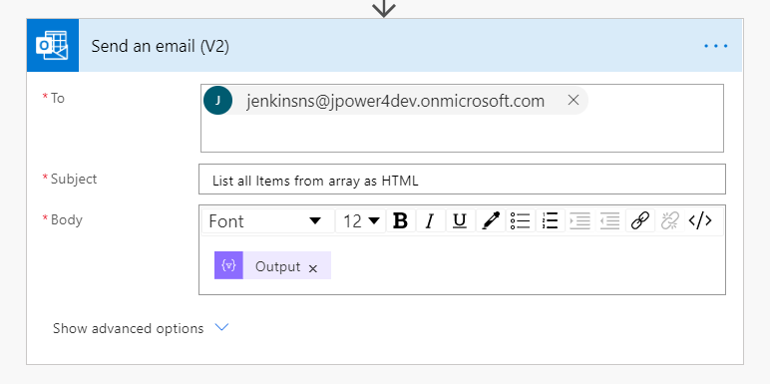

1. Save and test the flow